**Radio Button Properties**

* Continue with Lab 9, Add Radio Buttons

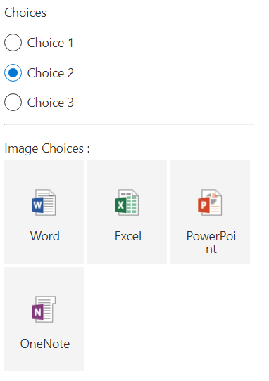

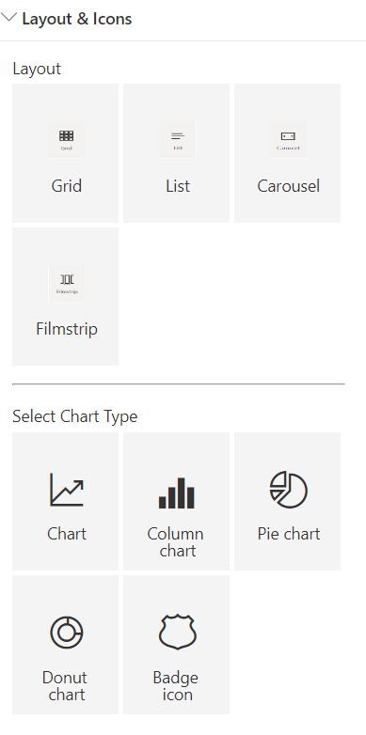

{

        header:{

          description:"Page 3 - Radio Buttons"

        },

        displayGroupsAsAccordion:true,

        groups:[

          {

            groupName:"Radio Buttons",

              isCollapsed:true,

              groupFields: [

                PropertyPaneChoiceGroup('radiobutton', {

                  label: 'Choices',

                    options: [

                      { key: 'Choice 1', text: 'Choice 1' },

                      { key: 'Choice 2', text: 'Choice 2', checked: true },

                      { key: 'Choice 3', text: 'Choice 3' }

                    ]

                }),

                PropertyPaneHorizontalRule(),

                PropertyPaneChoiceGroup('radiobuttonfiletype', {

                  label: 'Image Choices :',

                  options: [

                    { key: 'Word', text: 'Word',

                      imageSrc: 'https://jpower4mvp.sharepoint.com/Shared%20Documents/docx_32x1.png',

                      imageSize: { width: 32, height: 32 },

                      selectedImageSrc: 'https://jpower4mvp.sharepoint.com/Shared%20Documents/docx_32x1.png'

                    },

                    { key: 'Excel', text: 'Excel',

                      imageSrc: 'https://jpower4mvp.sharepoint.com/Shared%20Documents/xlsx_32x1.png',

                      imageSize: { width: 32, height: 32 },

                      selectedImageSrc: 'https://jpower4mvp.sharepoint.com/Shared%20Documents/xlsx_32x1.png'

                    },

                    { key: 'PowerPoint', text: 'PowerPoint',

                      imageSrc: 'https://jpower4mvp.sharepoint.com/Shared%20Documents/pptx_32x1.png',

                      imageSize: { width: 32, height: 32 },

                      selectedImageSrc: 'https://jpower4mvp.sharepoint.com/Shared%20Documents/pptx_32x1.png'

                    },

                    { key: 'OneNote', text: 'OneNote',

                      imageSrc: 'https://jpower4mvp.sharepoint.com/Shared%20Documents/one_32x1.png',

                      imageSize: { width: 32, height: 32 },

                      selectedImageSrc: 'https://jpower4mvp.sharepoint.com/Shared%20Documents/one_32x1.png'

                    }

                  ]

                }),

                PropertyPaneHorizontalRule()

              ]},

              {

                groupName:"Layout & Icons",

                  isCollapsed:false,

                  groupFields: [

                  PropertyPaneChoiceGroup('radiobuttonLayout', {

                  label: 'Layout',

                  options: [

                    { key: 'Grid', text: 'Grid',

                      imageSrc: 'https://jpower4mvp.sharepoint.com/Shared%20Documents/grid.png',

                      imageSize: { width: 32, height: 32 },

                      selectedImageSrc: 'https://jpower4mvp.sharepoint.com/Shared%20Documents/grid.png'

                    },

                    { key: 'List', text: 'List',

                      imageSrc: 'https://jpower4mvp.sharepoint.com/Shared%20Documents/list.png',

                      imageSize: { width: 32, height: 32 },

                      selectedImageSrc: 'https://jpower4mvp.sharepoint.com/Shared%20Documents/list.png'

                    },

                    { key: 'Carousel', text: 'Carousel',

                      imageSrc: 'https://jpower4mvp.sharepoint.com/Shared%20Documents/Carousel.png',

                      imageSize: { width: 32, height: 32 },

                      selectedImageSrc: 'https://jpower4mvp.sharepoint.com/Shared%20Documents/Carousel.png'

                    },

                    { key: 'Filmstrip', text: 'Filmstrip',

                      imageSrc: 'https://jpower4mvp.sharepoint.com/Shared%20Documents/Filmstrip.png',

                      imageSize: { width: 32, height: 32 },

                      selectedImageSrc: 'https://jpower4mvp.sharepoint.com/Shared%20Documents/Filmstrip.png'

                    }

                  ]

                }),

                PropertyPaneHorizontalRule(),

                PropertyPaneChoiceGroup('radiobuttonicons', {

                  label: 'Select Chart Type',

                  options: [

                    {

                      key: 'chart',

                      text: 'Chart',

                      iconProps: {

                        officeFabricIconFontName: 'Chart'

                      }

                    },

                    {

                      key: 'barchart',

                      text: 'Column chart',

                      iconProps: {

                        officeFabricIconFontName: 'BarChart4'

                      }

                    },

                    {

                      key: 'Pie',

                      text: 'Pie chart',

                      iconProps: {

                        officeFabricIconFontName: 'PieDouble'

                      }

                    },

                    {

                      key: 'donutchart',

                      text: 'Donut chart',

                      iconProps: {

                        officeFabricIconFontName: 'DonutChart'

                      }//https://developer.microsoft.com/en-us/fluentui#/styles/web/icons

                    },

                    {

                      key: 'Badge',

                      text: 'Badge icon',

                      iconProps: {

                        officeFabricIconFontName: 'Badge'

                      }//https://developer.microsoft.com/en-us/fluentui#/styles/web/icons

                    }

                  ]

                })

              ]

          }

        ]

      }